

**BLG 413E**

**SYSTEM PROGRAMMING**

CRN: 12300

**PROJECT #1**

Submission Date: 13.10.2014

**GROUP MEMBERS:**

MUSTAFA UÇAR 040100113

TUĞRUL YATAĞAN 040100117

EMRE GÖKREM 040100124

# **Introduction**

A group of functions written in Intel assembly language are called from a program in C. The main program reads two matrices, A and B from two files each containing one matrix. Then in a simple menu loop, the user gives the choice to select the matrix operation. The result of each operation are shown on screen. The program ends when the user selects the quit option from the menu.

Following functions are implemented, selection parameters are in parentheses:

**(a)** void add(int *matrix1, int *matrix2, int *result, int size);

**(s)** int sum(int *matrix1, int size);

**(m)** void mult(int *matrix1, int *matrix2, int *result, int size);

**(c)** void scale(int *matrix1, int number, int *result, int size);

**(u)** void square(int *matrix1, int *result, int size);

**(i)** void ITU(int *matrix1, int size);

**(q)** quit option

# **Compilation and Running**

The program can be compile, load and run by **compileAndRun.sh** script. Content of this script:

#!/bin/bash

rm -f *.o* #clear old object files

nasm -f elf32 add.asm

nasm -f elf32 sum.asm

nasm -f elf32 mult.asm

nasm -f elf32 scale.asm

nasm -f elf32 square.asm

nasm -f elf32 ITU.asm

gcc -c main.c -o main.o #compile c file

gcc main.o add.o sum.o mult.o scale.o square.o ITU.o -o hw1.out #load

./hw1.out #run

In this script, all assembly files are converted to object files by NASM;

nasm -f elf32 add.asm

C source file is compiled without loading by GCC;

gcc -c main.c -o main.o

And all object files are loaded by GCC;

gcc main.o add.o sum.o mult.o scale.o square.o ITU.o -o hw1.out

Finally elf32 executable file is executed;

./hw1.out

Example compilation and loading process is below:

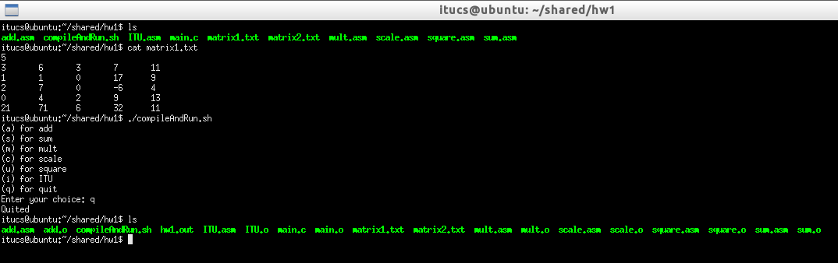

Example execution and outputs are below:

